MORGAN CITY HOUSING AUTHORITY

NEWSLETTER

FEBRUARY 2022
MORGAN CITY HOUSING AUTHORITY  P.O.BOX 2393 336 WREN ST.  MORGAN CITY, LA 70380  (985) 384-5118  (985) 385-2560 FAX  Visit us at Our Facebook Page @Morgan City  Housing Authority |  | OFFICE IS NOW FULLY OPEN TO RESIDENTS.  MON-FRI  7:30AM-4:30PM  LUNCH 12PM-1PM  MASK REQURIED | MCHA WILL BE ACCEPTING  APPLICATION ONLINE  WEDNESDAY, FEBRUARY 2ND FROM 8AM-3PM
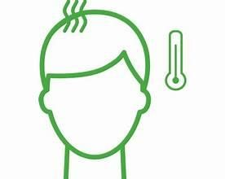  Please contact the office if you or anyone in your household have COVID OR showing signs of COVID.  - Fever or chills  - Cough  - Shortness of breath  - Muscle or body aches  - Loss of taste or smell | 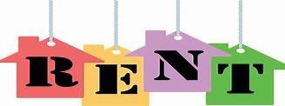  Rent is due February 1st. After the 5th a $20.00 late charge is added to the balance. If balance is not paid in Full be the 10th another $20.00 late charge will be added to the balance. Rent must be paid in Full by the 20th or Meters will be pulled for non-payment. |  | 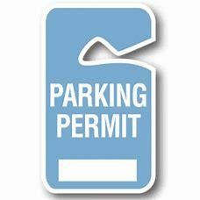  COMING SOON: Parking  permit will be required for residence. More information will be release at a later date.
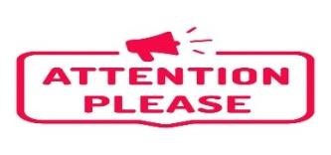  Rent statements are now available online to view. | TRASH PICK-UP DAYS!!  BROWNELL: Mondays & Thursdays  SHANNON: Tuesdays & Fridays  JACQUET: Mondays &Tuesdays  JOE RUFFIN: Mondays & Tuesdays |  | Due to increased Covid numbers, maintenance staff will only come out for emergency workorders such as LIGHTS, WATER AND GAS.

Pet permits are REQURIED for residence with pets. Any tenant with unregister pets in the unit, is in lease violation and can be evicted.

