

**Berwick Housing Authority**

**NEWSLETTER**

**DECEMBER 2023**

2019

 /

**Town of Berwick Presents**

**Christmas Movie Night**

**BERWICK CIVIC CENTER**

December 9 @ 6:00 pm

Pics w/Santa 6-7 pm

Showing Mickey’s Christmas Carol 7 pm

Hot Dogs, chips & drinks will be served

Bring pillows & blankets

**FREE FOR ENTIRE FAMILY!**



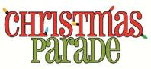

**December 15th**

Downtown Morgan City to Lawrence Park

Parade will roll down 2nd Street at 7 pm. Following the parade the movie **How the Grinch Stole Christmas** will play in Lawrence Park. Bring a blanket and chairs.

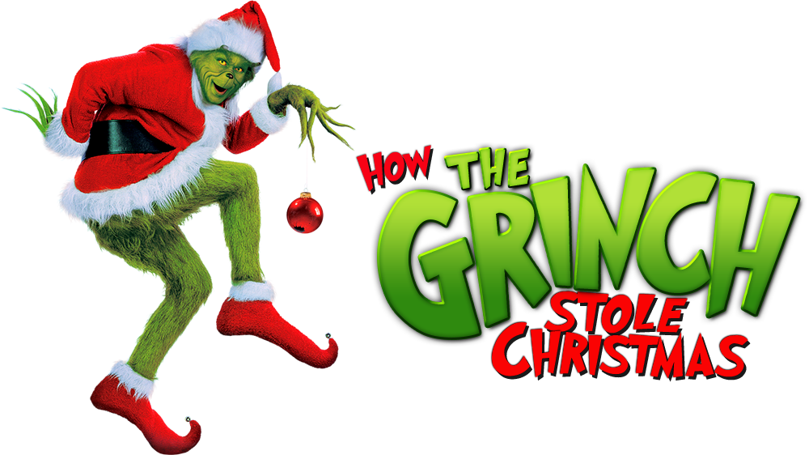

**2024 FLAT RENTS**

|  |  |  |
| --- | --- | --- |
| **BEDROOM SIZE** | **2024 FLAT RENTS** | **DIFFERENCE FROM 2023** |
| **0 BEDROOM** | **$534** | **$79** |
| **1 BEDROOM** | **$557** | **$48** |
| **2 BEDROOM** | **$730** | **$75** |
| **3 BEDROOM** | **$951** | **$106** |
| **4 BEDROOM** | **$1,179** | **$166** |

**IF YOU CURRENTLY PAY FLAT RENT, THE CHANGE WILL NOT AFFECT YOU UNTIL YOUR ANNUAL RECERTIFICATION**

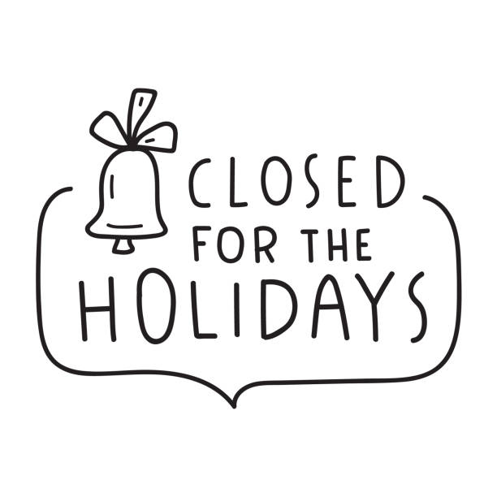

**Monday, December 25th and Tuesday, December 26th**

If you have a maintenance emergency (gas, water, electricity) please call the office and listen to the answering machine to get the phone number to the maintenance staff on call.



The **Town of Berwick** has a garbage can ordinance that states all garbage cans **MUST** be removed from the street shortly after collection of the contents has been made.



If you are employed, we will send a late contract to you with your December rent statement. By signing, this will give you until the 15th of the month to pay your rent without getting a strike. **YOU** **MUST SIGN A NEW LATE AGREEMENT CONTRACT EVERY** **YEAR**! Please sign the contract and drop it off at the office by **Friday, December 15th.**

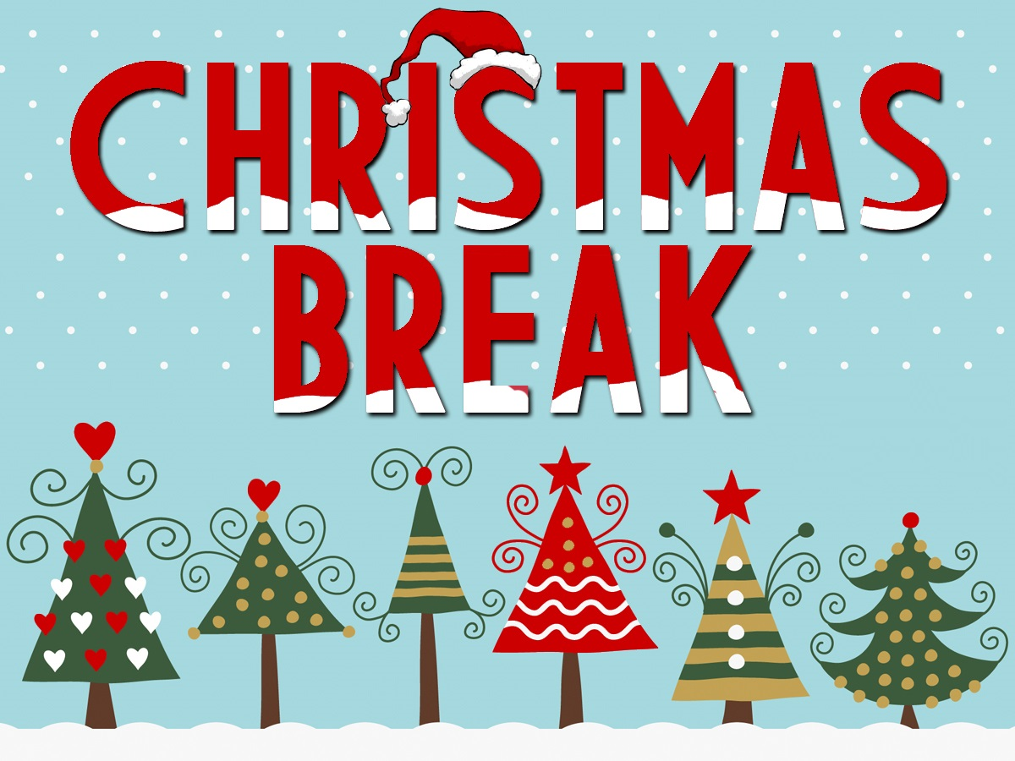

**Early Release-December 21st**

**December 22nd-January 5th**



**REMINDER TO PLEASE BRING IN YOUR SOCIAL SECURITY AWARD LETTER WHEN YOU RECEIVE IT** **IN THE MAIL**. We will keep a copy on file until your annual recertification. **The increase WILL NOT affect your rent until your annual recertification is due.** The Cost of Living Adjustment for 2024 will be 3.2%.



**BERWICK TOWN MARKET**

**Saturday, December 16th**

Under US 90 bridge on the corner of Third & Lima Streets

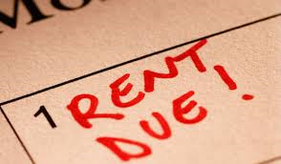

Rent is due **December 12th** which is the eighth working day of the month. If you do not pay by **December 12th**, a $10 late fee will be applied. If you signed a contract, your rent is due **December 15th**, but a late fee is still applied after the **12th**. The absolute last day to pay the rent is **December 20th**.



Reminder that pest control spraying will be on **FRIDAY,** **DECEMBER 8TH**. You do not have to be home, but if you are home and refuse to allow them inside, you will be charged. Also, remember that 3 housekeeping notices results in eviction. **THE MOST IMPORTANT PART OF ELIMINATING ROACHES IS TO SWEEP OUT OR VACUUM DEAD ROACHES FOR THE CABINETS, DRAWERS AND ALL APPLIANCES AT LEAST ONCE A WEEK!**

**Berwick Housing Authority**

**P.O. Box 231**

**2751 Fifth Street**

**Berwick, LA 70342**

**(985) 385-1546 office**

**(985) 385-5840 fax**

**berwickhousing@berwickhousing**

**authority.com**

**Visit our website:**

**Berwickhousingauthority.com**